**Excel Assignment – 13**

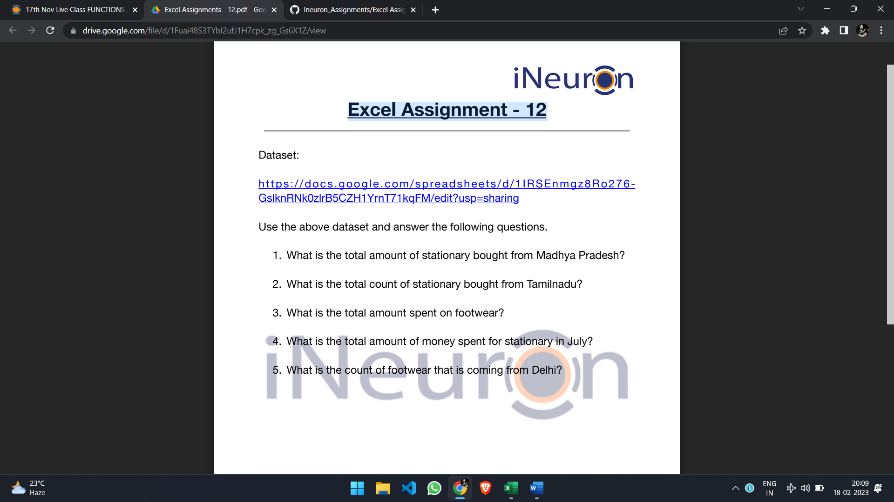

**1. What is the total amount of stationary bought from Madhya Pradesh?**

**1,76,971**

**2. What is the total count of stationary bought from Tamilnadu?**

Count of stationary is **13**.

**3. What is the total amount spent on footwear?**

Total amount spent is **1,94,226.**

**4. What is the total amount of money spent for stationary in July?**

Total amount of money spent for stationary in July was **53,398**.

**5. What is the count of footwear that is coming from Delhi?**

Count of footwear coming from Delhi is **2**.

**Results**

To make my analysis easy I made a pivot table which helped me to showcase the numbers in tabular form.

